Assignment Find

Search and display all \*.c and \*.h files in all subdirectories starting from current directory

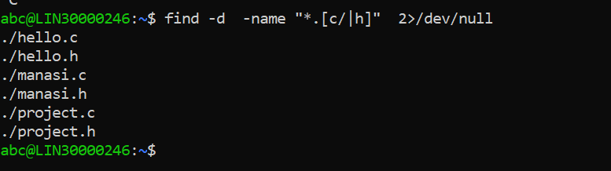

Search and display all directories in all subdirectories starting from current director

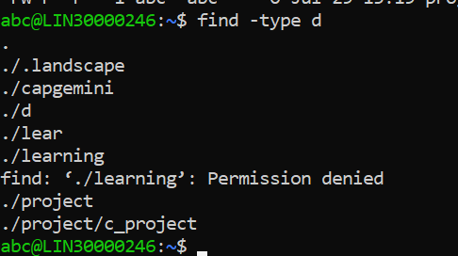

Search and display all files with permissions only rw with user and execute permission for others

